*SOFTWARE DESIGN SPECIFICATION*

**1.0 Introduction**

This Software Design document describes all data, architectural, interface and component-level design for the Online Food Recipes application.

**1.1 Goals and objectives**

The design of the Request Us form in Chatrasahaya application involves the design of forms for requesting, the request can be for self or can be for others also.

**1.2 Statement of scope**

The user can Request for any service provided by the Chatrasahaya through the Request Us form.

There will be a tab called Request Us which pops up a form to fill up, it contains all the necessary details for requesting.

After requesting the user will be notified on the further process.

**1.3 Major constraints**

1. A full internet connection is required for the chatrasahaya Application to run properly.

2. User should provide the government id and request details such as category,location,name and other details in the Request Us form

**2.0 Data design**

A description of all data structures and databases.

**2.1 Data structures**

Data structured that are available to major portions of the architecture are shown below in table and digaram as well

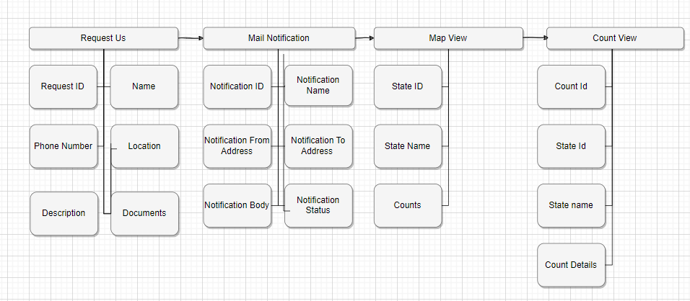

**2.2 Database description**

Database(s) created as part of the application is(are) described.

Below is the table designed for application.

UserRequests,MailNotification , UserRequests can be used for the Map & Count View

|  |  |  |  |
| --- | --- | --- | --- |
| **UserRequests** | **Mail Notification** | **Map View** | **Count View** |
| Customer ID: Int | Notification ID : Int | State ID: Int | Count ID: Int |
| Name: String | Notification Name: String | State Name: String | State ID: Int |
| Phone Number: BigInt | Notification To Address : String | Count: Int | State Name:String |
| Location: String | Notification From Address : String |  | Count Details : Table with Request Name,Request Phone Number,Location,Description,Documents View |
| Description: String | Notification Body: String |  |  |
| Documents: Img,Pdf Uploads | Notification Status  : String |  |  |

**3.0 Architectural and component-level design**

**3.1 Architecture Logical View**

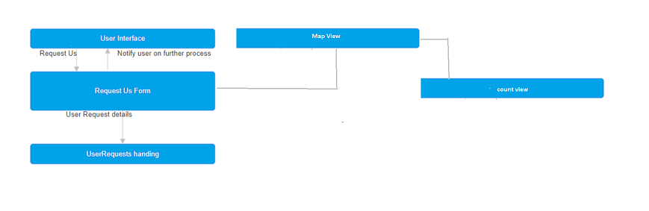Architecture Logical view diagram for Request US,Map View & Count View and below is the explanation for the levels :

**3.1.1 User Interface**

User Interface is a function that user can interact with application and perform certain actions like viewing of counts in map and counts details and can request services from Chatrasahaya with a new feature Request Us

**3.1.2 Request Us form**

This is the main function which allows user to request for the services provided by Chatrasahaya

3.1.3 **Mail Notification:** After End users clicking on Submit button with the valid data , A mail will be sent to the **chatrasahaya** team mail id to get to know the requester details.

**3.1.4 Map View**

This is the function where Users/Team can see the counts of the request services provided by Chatrasahaya team on the map view

**3.1.5 Count View**

This is the function where Users/Team can see the details such as name of the requester,location & category… of the counts on the map view

**3.2 Architecture Process View**

The below figure show the process views of the requests which was happening in the application

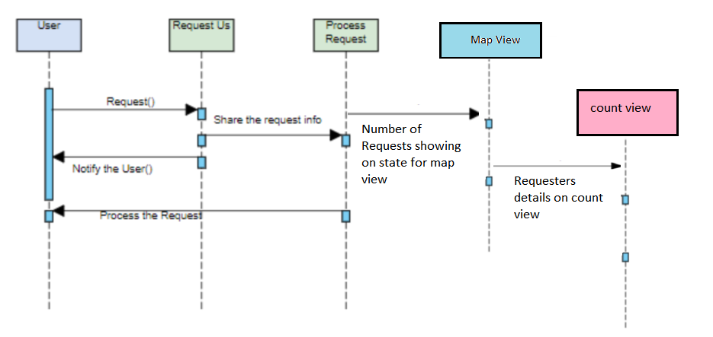

**3.3 Architecture Development Diagram**

The below figure show the development views of class fields of all the components using for the development and briefly explain in the components section

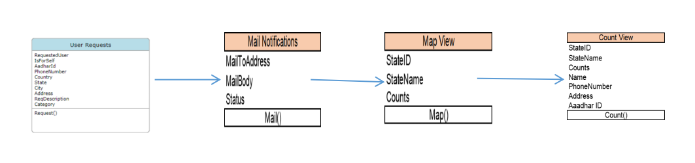

**3.4 Architecture Deployment Diagram**

The below figure show the deployment views of the features and also testing stages in parallel with the deployment & development

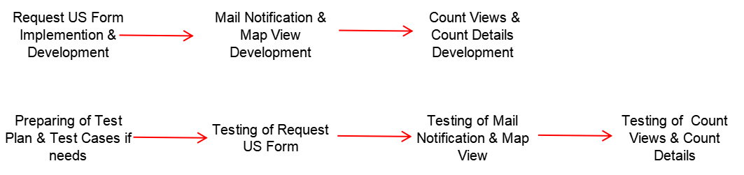

**3.4 Architecture Usage Scenario Diagram**

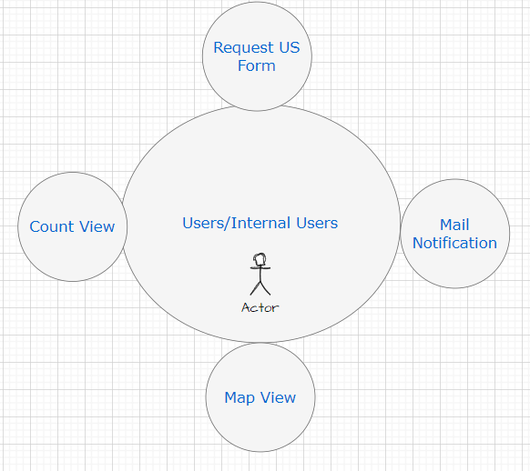

**User:**

1. **Request Us**

If customer wants to request us the required needs to the low budget schools , this page can be useful to submit the details of location,proofs.

1. **Mail Notification**

Our internal team can receive the mail after submitting the request us details

1. **Map View**

User can know the no of requests completed in the map by state level

1. **Count View**

User can know the details of the each count like request location,requester name, request items etc…

**3.2 Description for Components**

Major enhancement/Components in our web application are:

* Request Us form
* Mail Notification
* Map View
* Count View

**3.2.1 Request Us Form**

**Form to accept Request :** User can request for the services provided by Chatrasahaya and user can see the counts in the map on state view along with requester details in count view

**3.2.1.1 Interface Description**

**Input :** User Data such as Name , Phone Number,Address , Proof of documents are the input data which needs to navigate to the Map View Page by clicking on Add Request Button.

**Output :** Mail Notification and showing the count in the Map view

**Exceptions :** If the User submit the invalid data we will show the alerts as exceptions while submitting the Form

**3.2.1.2 Static models**

Here is the below is the Class diagram for the User Request



**3.2.2 Mail Notification**

Sending the mail notification to the team after user submitting the request either by self for the others

**3.2.2.1 Interface Description**

**Input :** Successfully Submitting of the form

**Output :** Sending the mail to the team

**Exceptions :** Sometimes mails will be delay in deliver to the team

**3.2.2.2 Static models**

Here is the below is the Class diagram for the Mail Notification

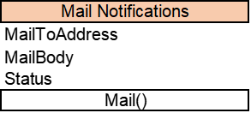

**3.2.3 Map View**

Showing of the Requests successfully completed service as showing the counts in the Map View

**3.2.3.1 Interface Description**

**Input :** Sending of the Mail and Submitting of the Request Us form successfully

**Output :** Showing of the count in the map based on the

successfully request

**Exceptions :** Showing of extract counts will be chance when same state request us submissions happen at once

**3.2.3.2 Static models**

Here is the below is the Class diagram for the Map View

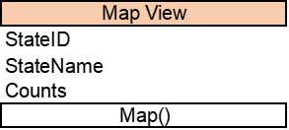

**3.2.4 Count View**

Showing of the Requester details when user clicks on counts on the states of the map view

**3.2.4.1 Interface Description**

**Input :**  Counts on the map view

**Output :** Showing of the requester details such as name , phone number,address ,proof of documents

**Exceptions :** Showing of correct details will be thing and related documents

**3.2.4.2 Static models**

Here is the below is the Class diagram for the Count View

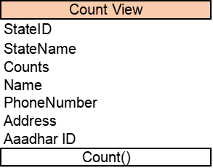

**3.2 Dynamic models**

**3.2.1 Activity diagram:**

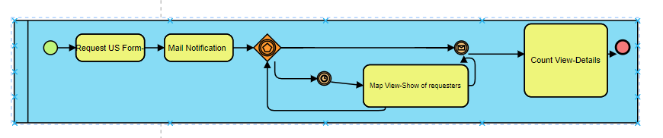Activity diagram for Request Us & Map view , Count View

**3.2.1.2 Sequence diagram:**

The below show the sequence diagram for the Request Us form,Mail Notification,Map View,Count View



Sequence diagram for Request Us & Process Request(Mail Notification),Map view , Count View

**3.3 External Interface Description**

The software interface(s) to the outside world is(are) described.

**3.3.1 External machine interfaces**

Interfaces to other machines (computers or devices) are described.

1. Operating System: Windows 11
2. Microsoft Visual Studio
3. WordPress PHP on Go-daddy itself
4. Microsoft SQL Server Management Studio
5. Java/python Development Toolkit.

**4.0 User interface design**

**4.1 Description of the user interface for Request Us**

Below is the image for the Request US form where user can request the service Chatrasahaya

Request Us Page

**4.2 Description of the user interface for Map View & Count View**

Below is the image for the Map View & Count View where user can

see the counts on the states where services has been completed raised by the Requester , When user clicks on counts such as 5,2 on below screenshot will display the Service details such as Name, Location,Proof of Documents and Description is Count View.

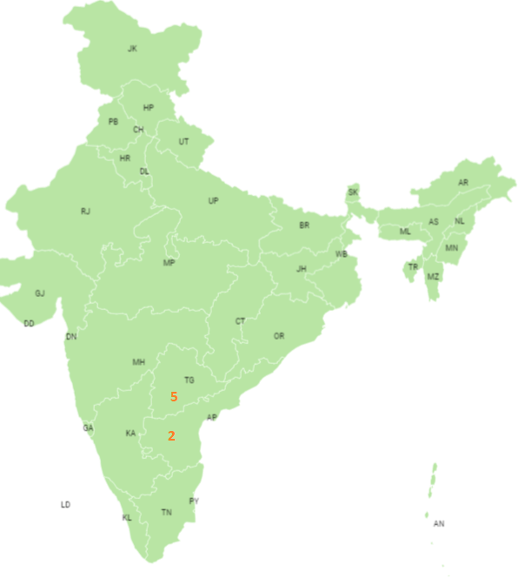

**4.2 Interface design rules**

* Our application should be reachable and easy to use for all users.
* Request us form should be user friendly
* Application response time should be less when user clicks on an event.
* User response messages should be simple enough to understand.

**5.0 Restrictions, Limitations, and Constraints**

Special issues which impact the specification, design, or implementation of the software are noted here.

1. A full internet connection is required for the application to run properly.
2. For the Map View , Integrating of google maps will be challenged task and UI Alignments as well
3. Showing of the counts under the State Name from the database table counts will be time taking process
4. Updates in the Google Maps may impacts the Map view

**6.0 Appendices**

Presents information that supplements the design specification.

**6.1 Requirements traceability matrix**

|  |  |  |  |  |  |
| --- | --- | --- | --- | --- | --- |
| **Traceability Matrix** | | | | | |
| **Project Name:Chatrasahaya** | | | | | |
| **Purpose:** To manage requirements throughout the software development lifecycle. The Traceabilty Matrix ensures that requirements are captured in the design, implemented in the code, and verified by testing. | | | | | |
|  |  |  |  |  |  |
| **Use Case** | **Requirement Number** | **Requirement Description** | **Test Case** | **Design Component / Module** | **Comments** |
| Request US Form | CS_001 | End Users can request the services from this form either for self or for others by using proof documents,Name,Location and other details | TCS_001 | Request US Form - Name , Location,Phone Number,Aaddhar Number , Proof of documents file upload |  |
| Mail Notification | CS_002 | After End users clicking on Submit button with the valid data , A mail will be sent to the chatrasahaya team mail id to get to know the requester details. | TCS_002 | Mail Notification with the Requester Details |  |
| Map View | CS_003 | Users/Team can view the Counts on the Map for the State as how many services has been sponered or completed by the Chatrasahaya team | TCS_003 | Map View - Counts on the States |  |
| Count View | CS_004 | Users/Team can view the details such as Name , Location,Phone Number,Aaddhar Number , Proof of documents files of the Counts on the Map for the State as how many services has been sponered or completed by the Chatrasahaya team | TCS_004 | Count View - Viewing of the Infromation such as Name , Location,Phone Number,Aaddhar Number , Proof of documents file upload |  |